Index in sql

<https://youtu.be/VrQuOkY6ZbM>



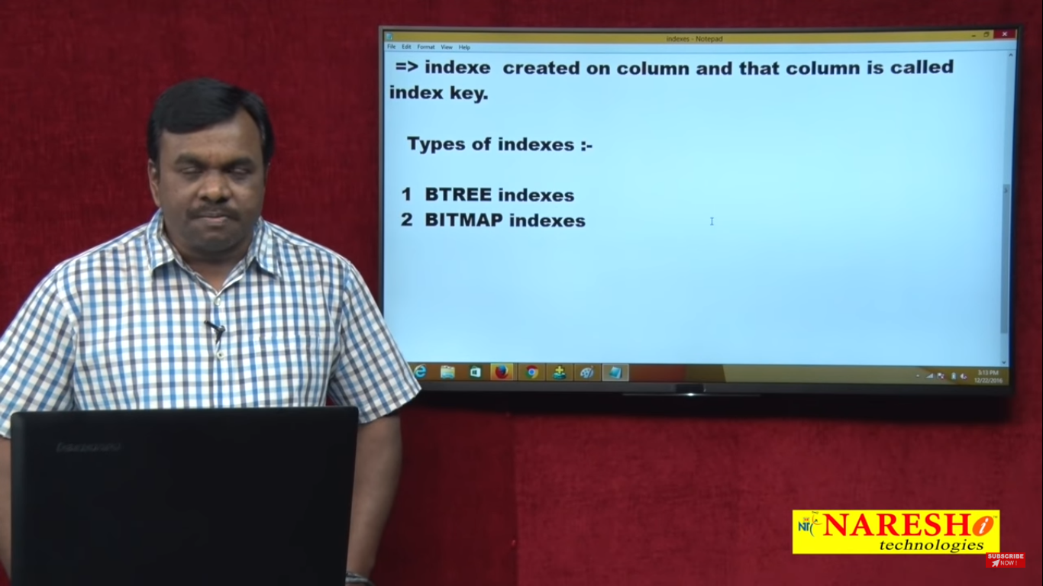

Imp : Index’s are created on table column

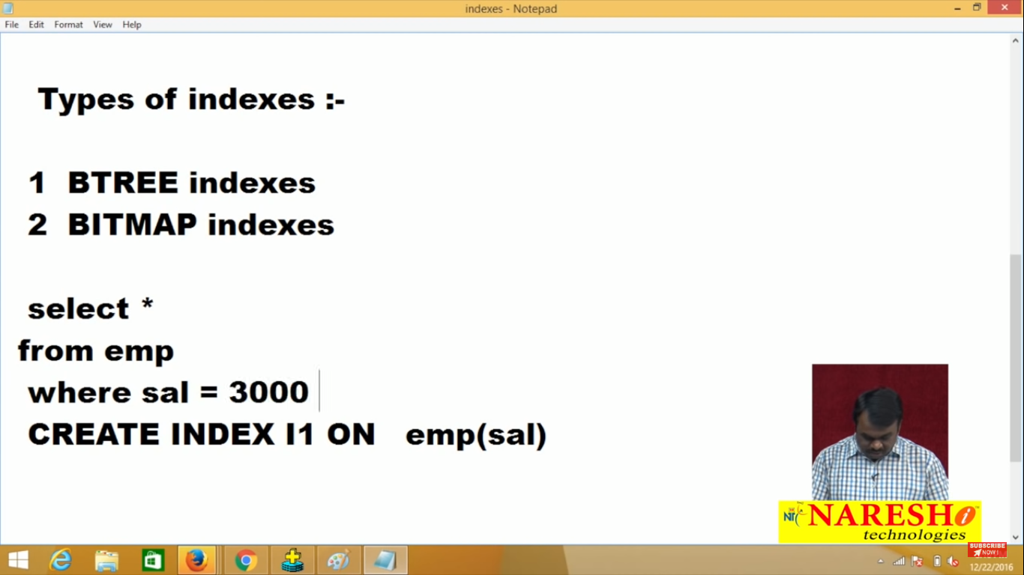

Note : If search is based on salary so create index for salary, if search is based on enum then create index for enum(in where condition )

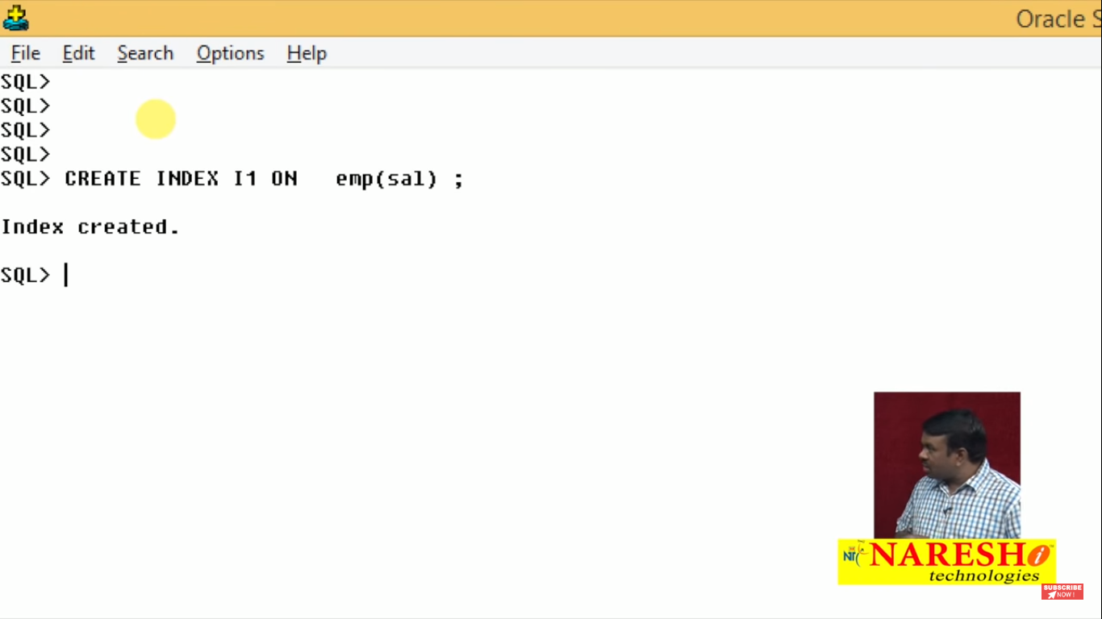

Note : Bydefault **bitree** Index will be created and internally one structure will be created and that structure look a like as tree

For Emp table index salary



Like this

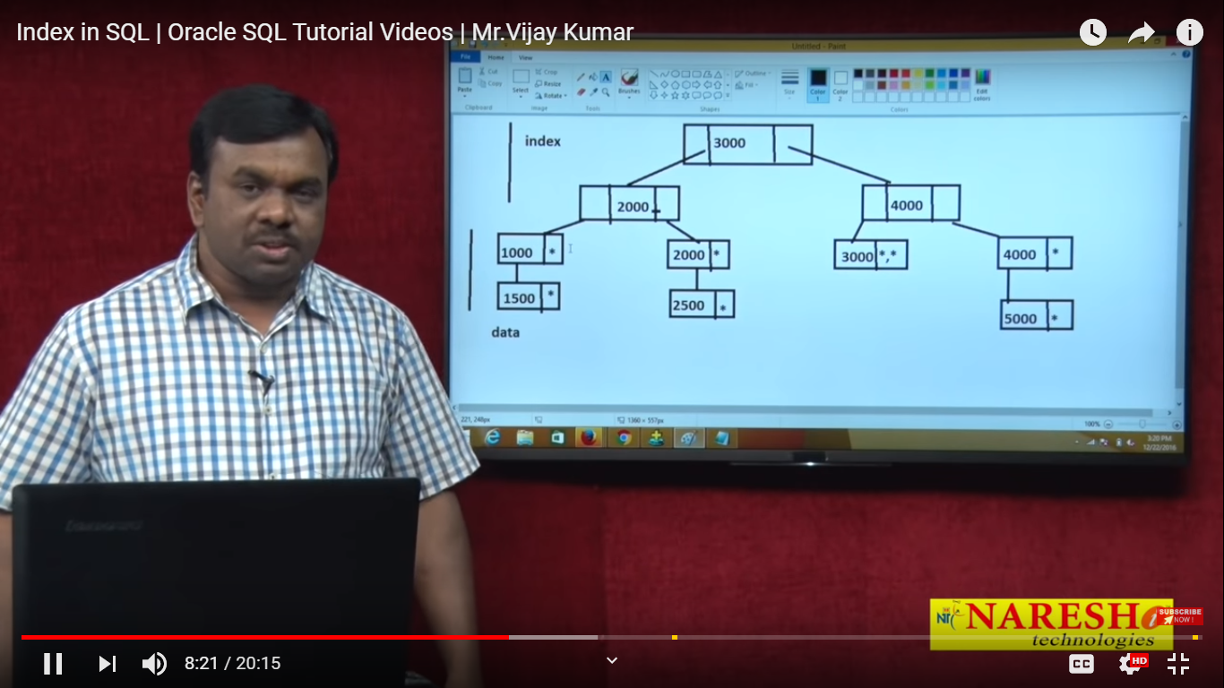

Each and every node has a left pointer and right pointer and every data node contain node value(Index key) and start *.

Every data node point a record ex : 1000 and * (Row id)

Using this structure Oracle find very fast data record

V Imp : If you see above digm top node has 3000 and leftpointer has less then 3000 that means 2000 and right pointer is 4000 which is greater then 3000 and so on

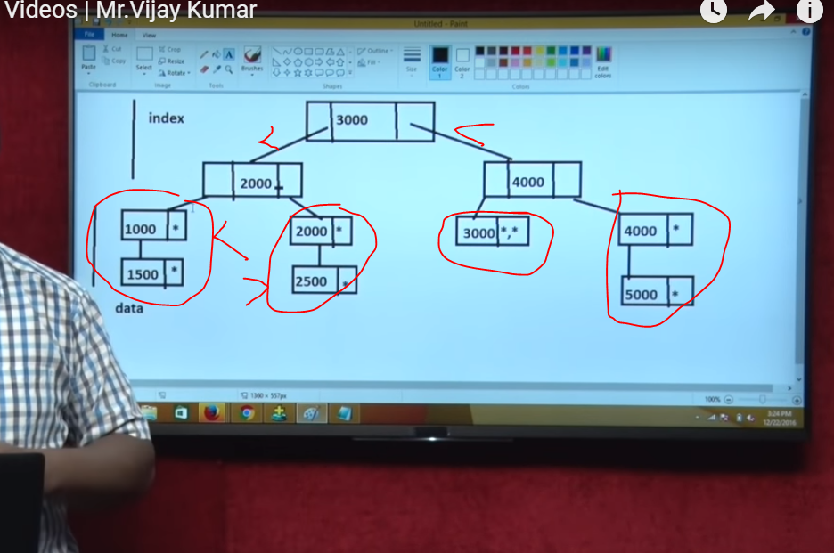

Example if have query select * from emp where sal=3000;

There is two way oracle search data table scan and data scan

If index is not there then it will do table scan

Note : Table scan is linear search which takes more time compare to index search because linear search go one by one example



Now Index search :

If you submit this quarry select * from emp where sal=3000;

Index is like book index based on this index you can go to value, top one is index and down one is value

You are seeing *,*(two row ids) that means two employee having 3000 sal

Note : here by doing three compariesgn we will get our search

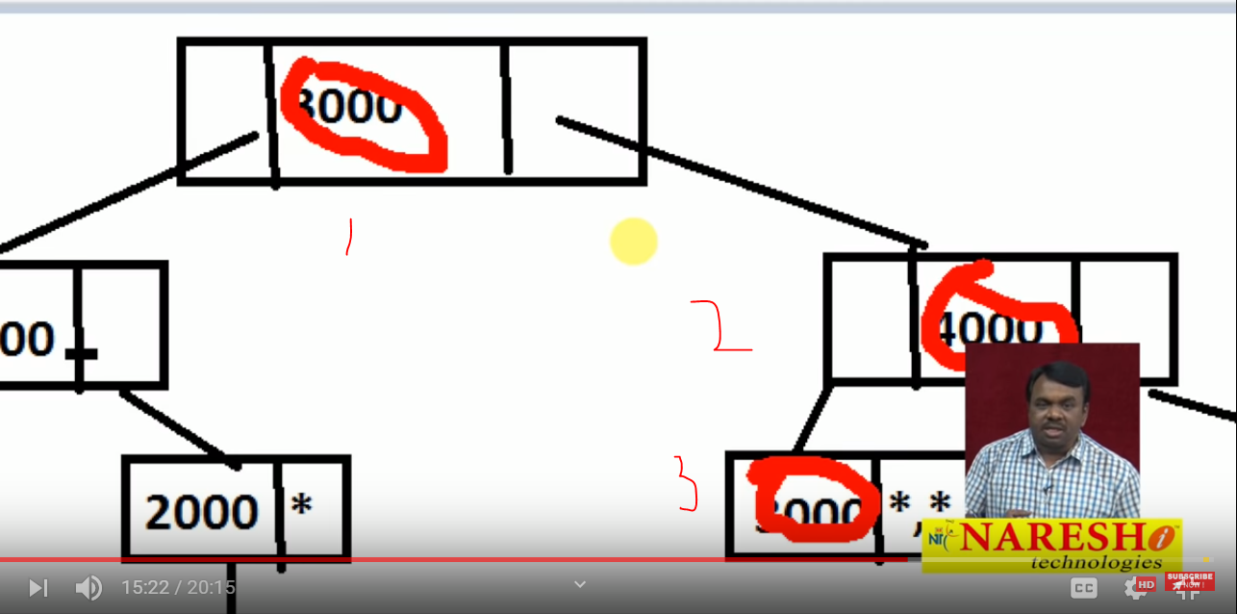

Index compression is more efficient here

Note: seeing how oracle see search records either table scan or index scan type this command



After exciting this commond excuite your query on along with result you will get excuion plan (table scan or index scan)

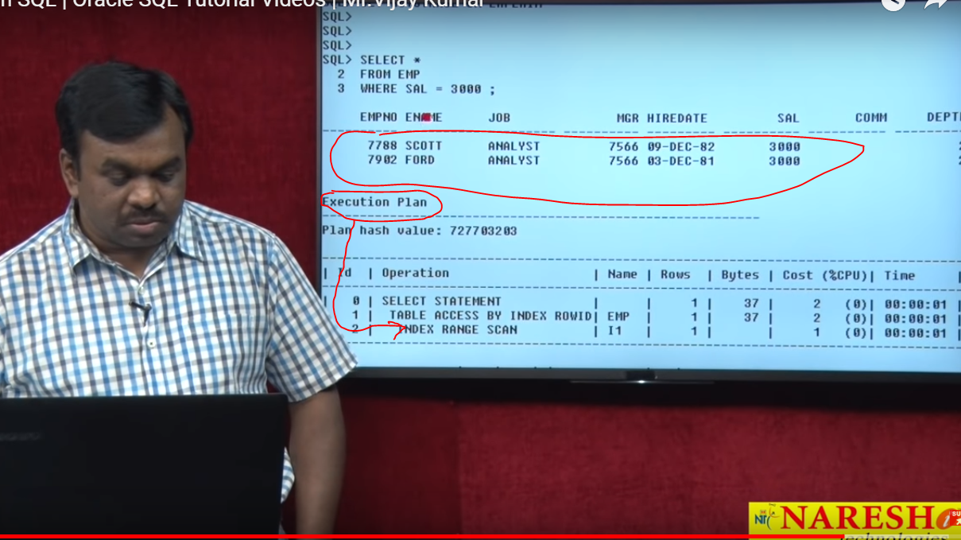

For this query also it will search index serch

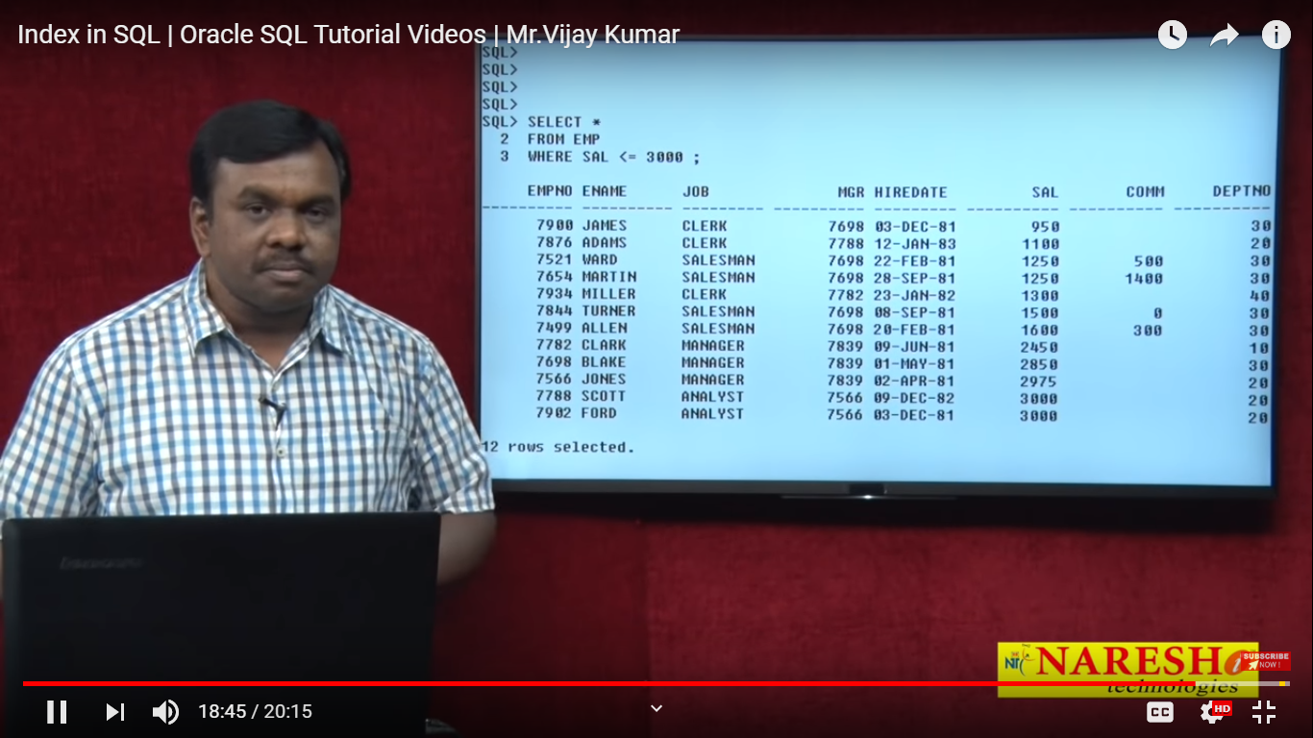

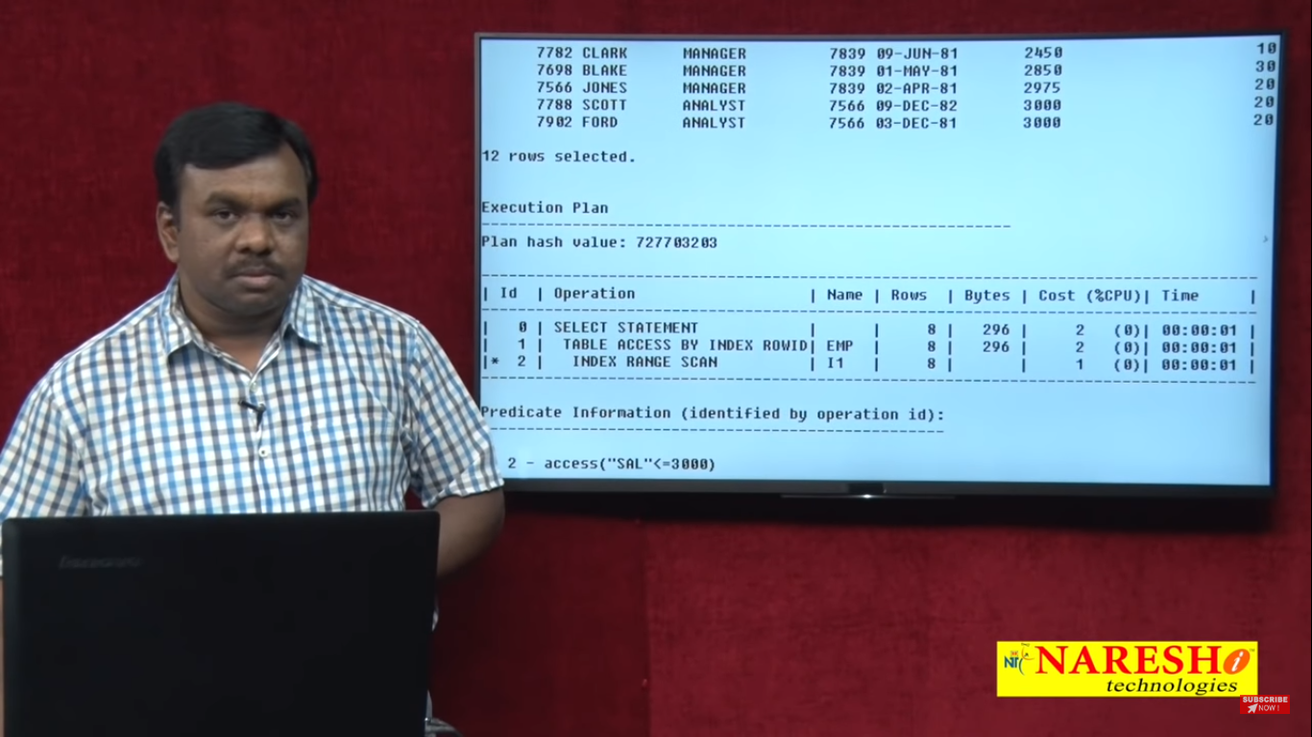

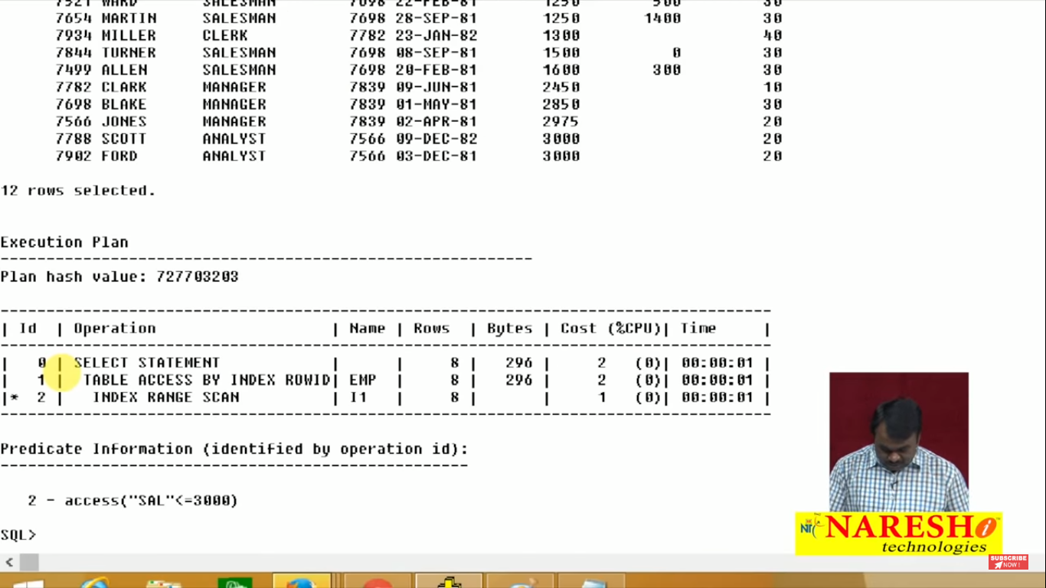

If use this query you will get table scan

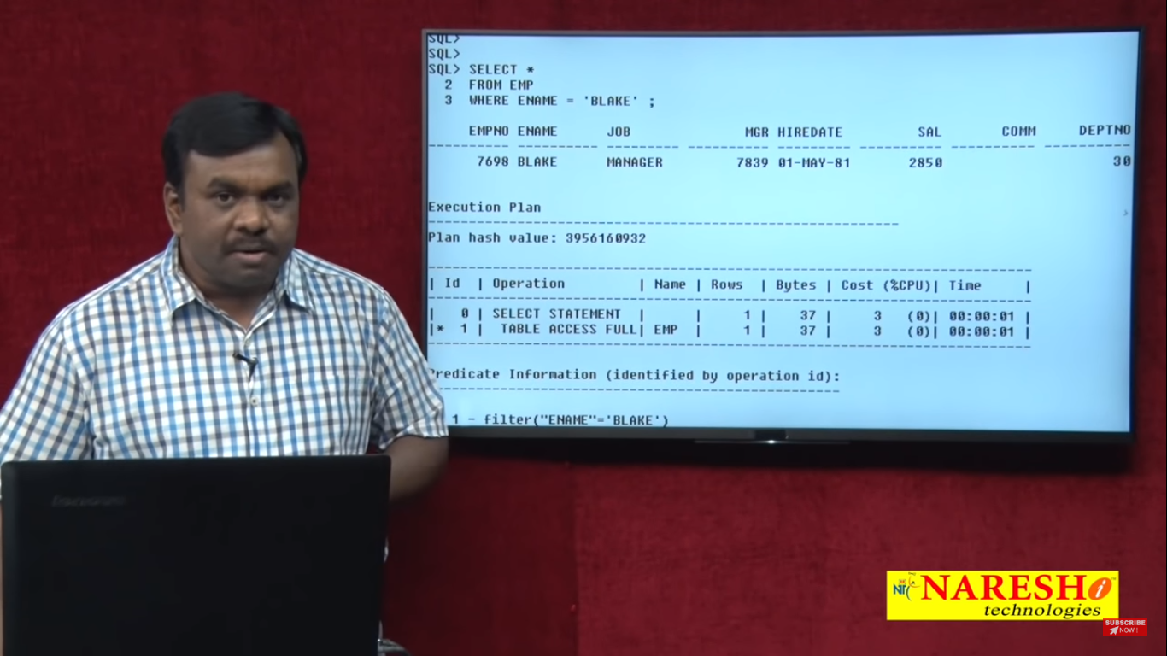

You have created index for salary but searching ename that resion oracle uses table scan

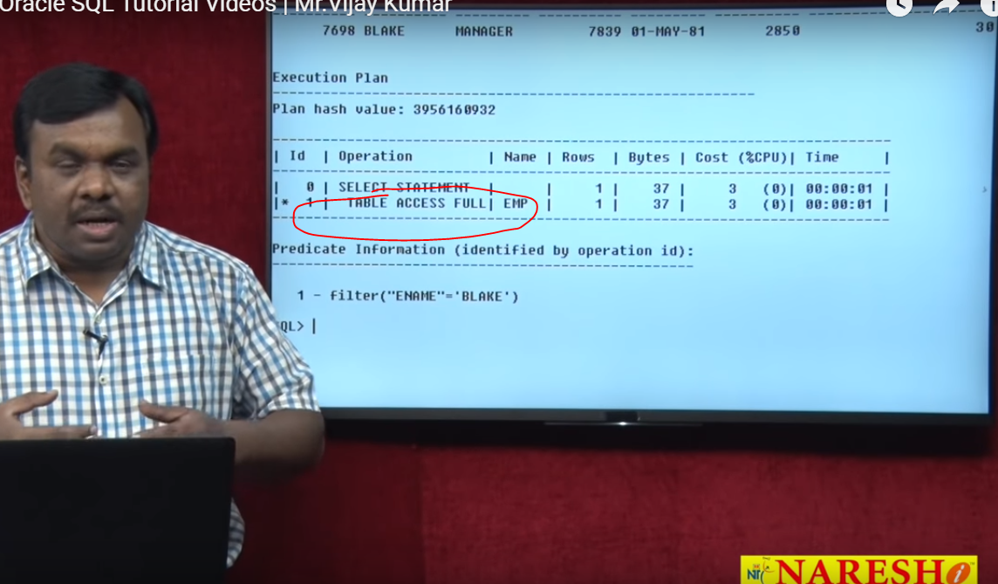

### Unique Indexes

Unique indexes are used not only for performance, but also for data integrity. A unique index does not allow any duplicate values to be inserted into the table. The basic syntax is as follows −

CREATE UNIQUE INDEX index_name

on table_name (column_name);

## Partial Indexes

A partial index is an index built over a subset of a table; the subset is defined by a conditional expression (called the predicate of the partial index). The index contains entries only for those table rows that satisfy the predicate. The basic syntax is as follows −

CREATE INDEX index_name

on table_name (conditional_expression);

## Implicit Indexes

Implicit indexes are indexes that are automatically created by the database server when an object is created. Indexes are automatically created for primary key constraints and unique constraints.

### Example

The following is an example where we will create an index on [COMPANY](https://www.tutorialspoint.com/postgresql/company.sql)table for salary column −

# CREATE INDEX salary_index ON COMPANY (salary);

Now, let us list down all the indices available on COMPANY table using **\d company** command.

# \d company

This will produce the following result, where *company_pkey* is an implicit index, which got created when the table was created.

Table "public.company"

Column | Type | Modifiers

---------+---------------+-----------

id | integer | not null

name | text | not null

age | integer | not null

address | character(50) |

salary | real |

Indexes:

"company_pkey" PRIMARY KEY, btree (id)

"salary_index" btree (salary)

You can list down the entire indexes database wide using the **\di** command −

## The DROP INDEX Command

An index can be dropped using PostgreSQL **DROP** command. Care should be taken when dropping an index because performance may be slowed or improved.

The basic syntax is as follows −

DROP INDEX index_name;

You can use following statement to delete previously created index −

# DROP INDEX salary_index;

## When Should Indexes be Avoided?

Although indexes are intended to enhance a database's performance, there are times when they should be avoided. The following guidelines indicate when the use of an index should be reconsidered −

* Indexes should not be used on small tables.
* Tables that have frequent, large batch update or insert operations.
* Indexes should not be used on columns that contain a high number of NULL values.
* Columns that are frequently manipulated should not be indexed.